**IT 453. Hands-on exercises.**

**Class work/Homework 1.**

**Resources:**

* **Use as a reference “Oracle Database 11 g Administrator. Certified Associate”,**

**“Maintaining the Database and Managing Performance” - ch.14 .**

**Hands-On:**

1. **Use database Control to monitor undo and undo tablespace**

**EM > SERVER tab**

**> Automatic Undo management**

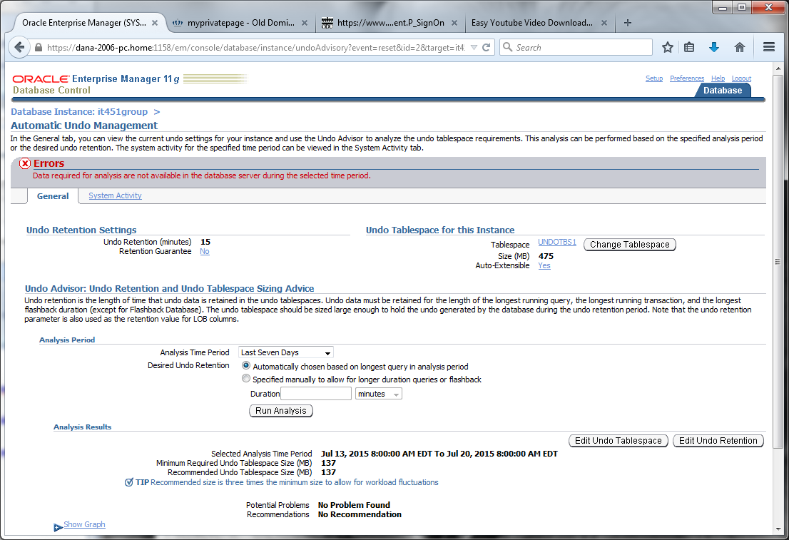

**EM > SERVER tab**

**> Automatic Undo management**

**>change Table space button**

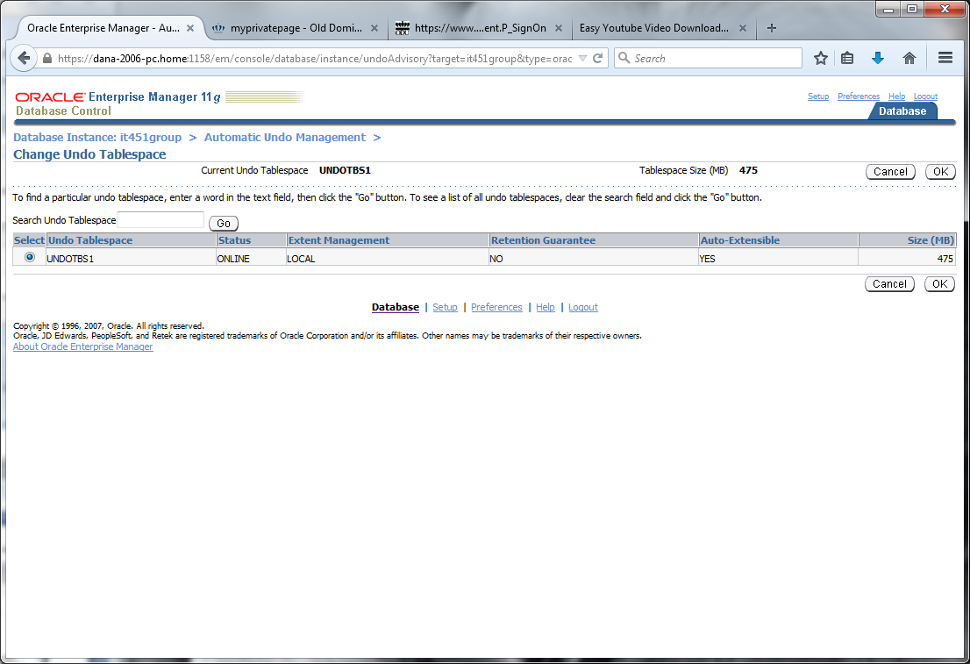

**(from automatic Undo management tab)**

**>Table Spaces**

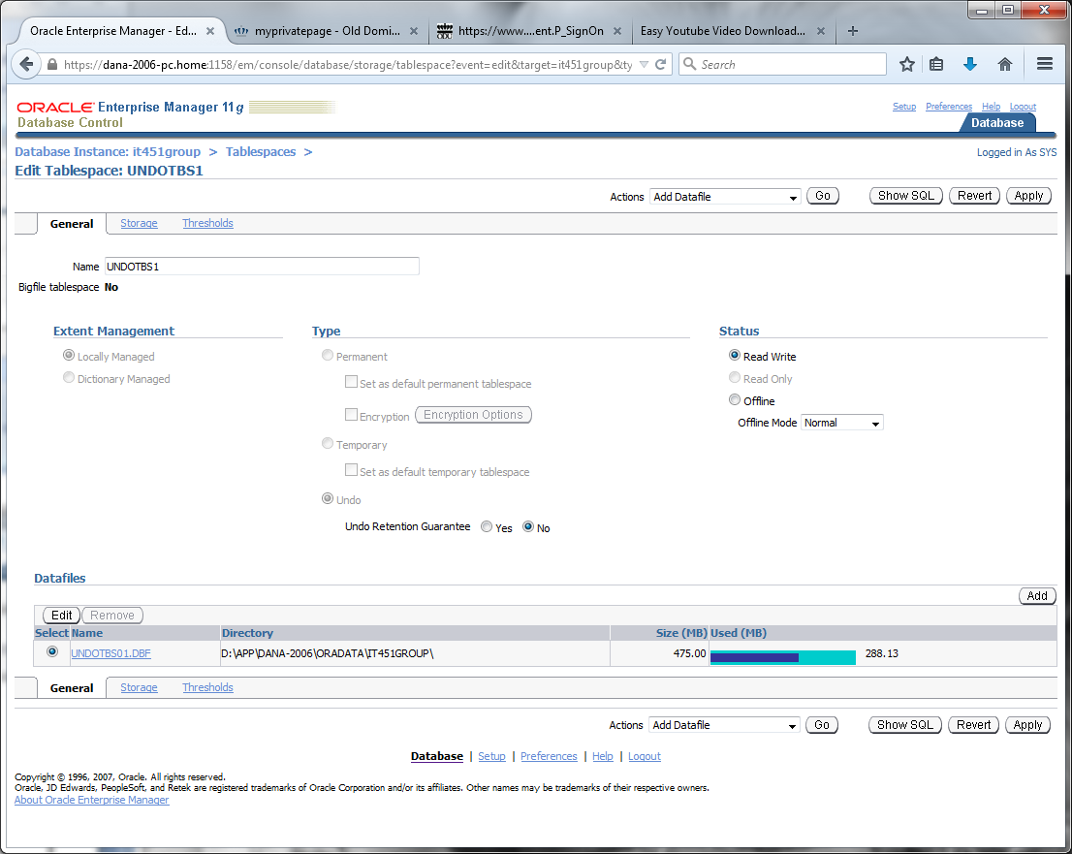

1. **Use database Control to gather statistics on schema/database**

**>manage optimizer statistics**

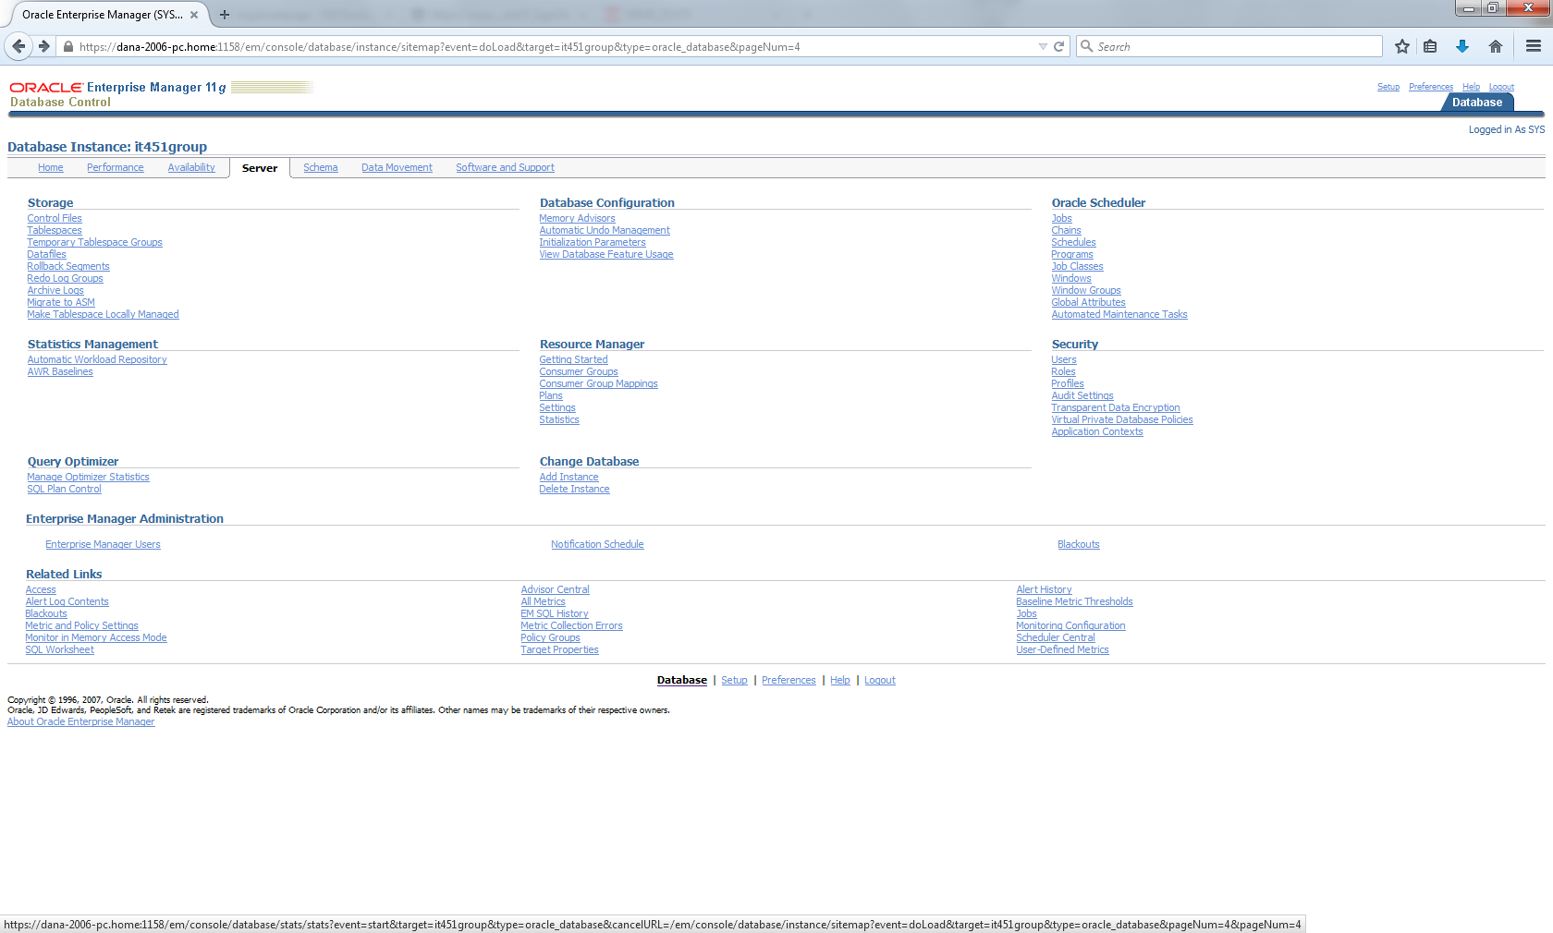

**>gather optimizer statistics**

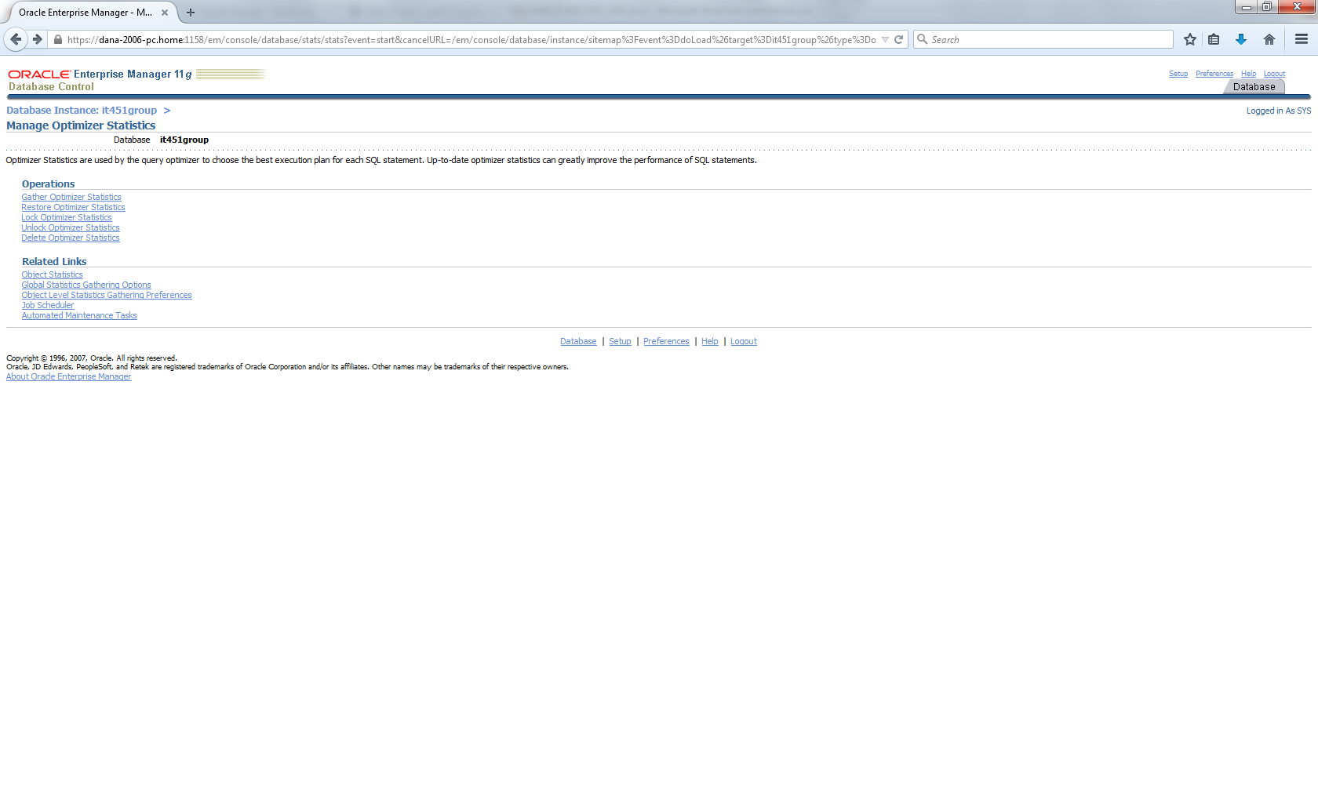

**>Step1**

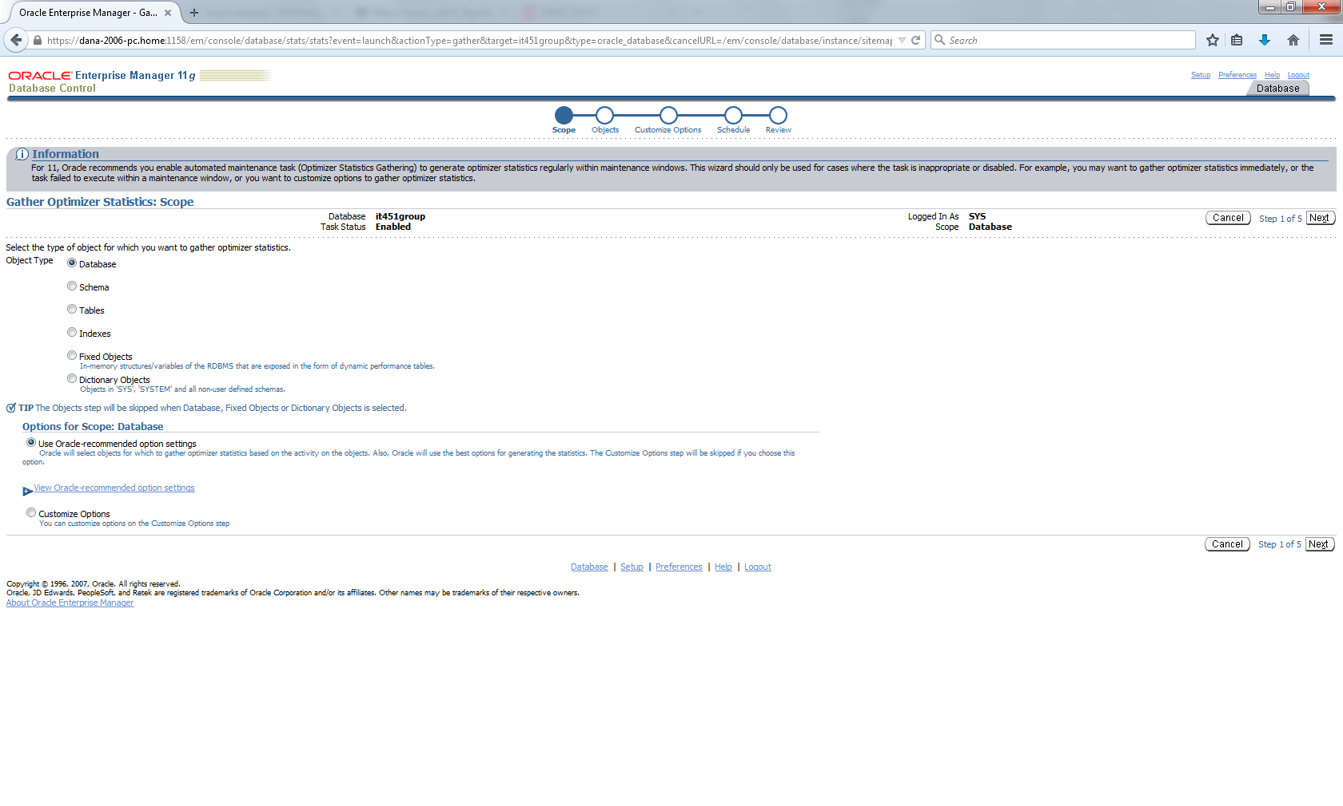

**>Step4**

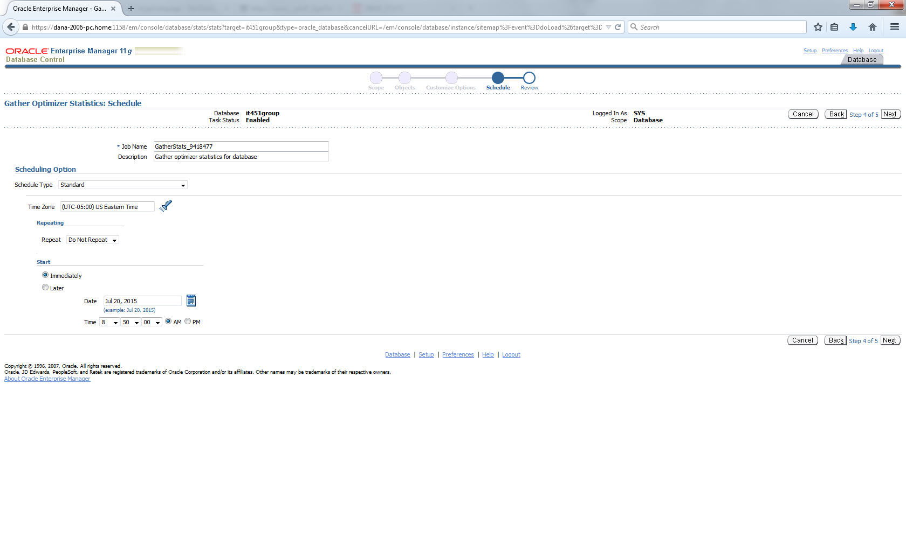

**>Step 5 then submit button**

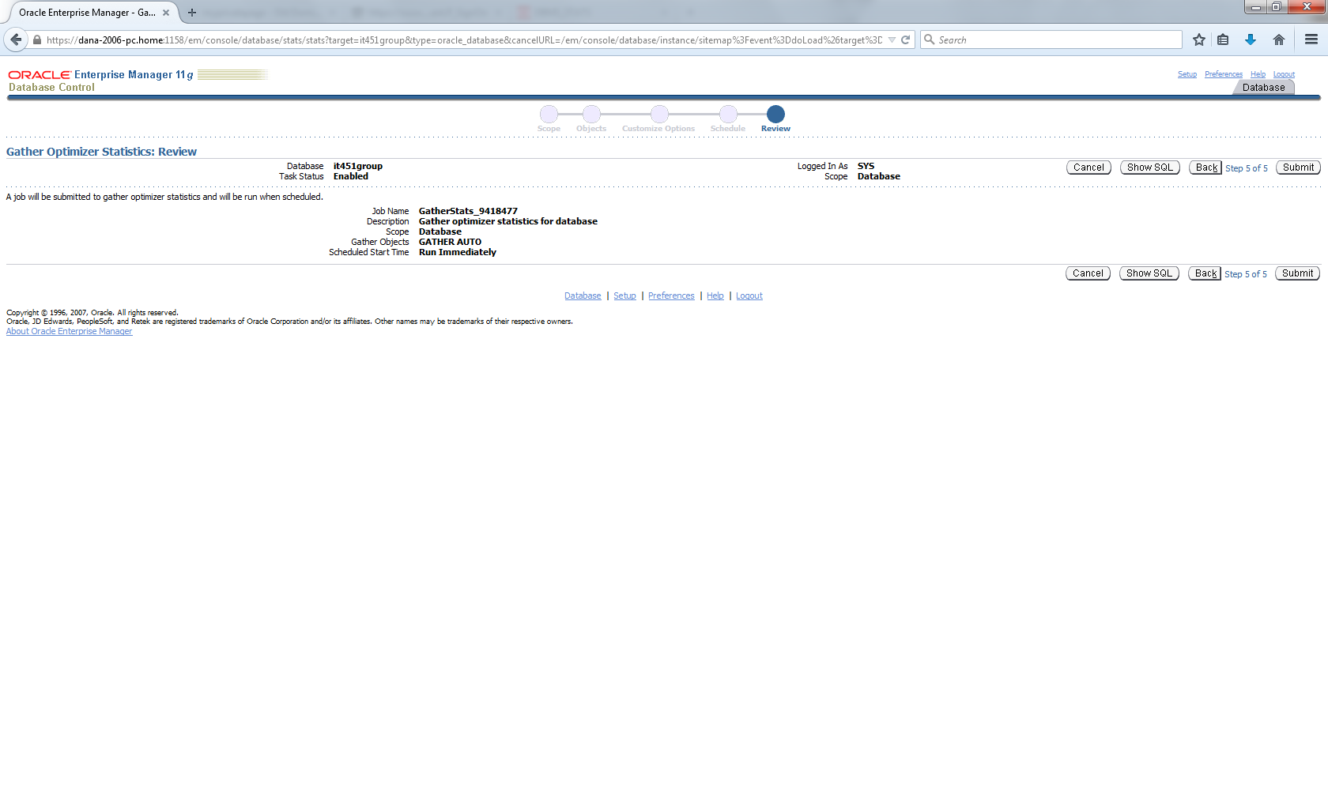

**Results page:**

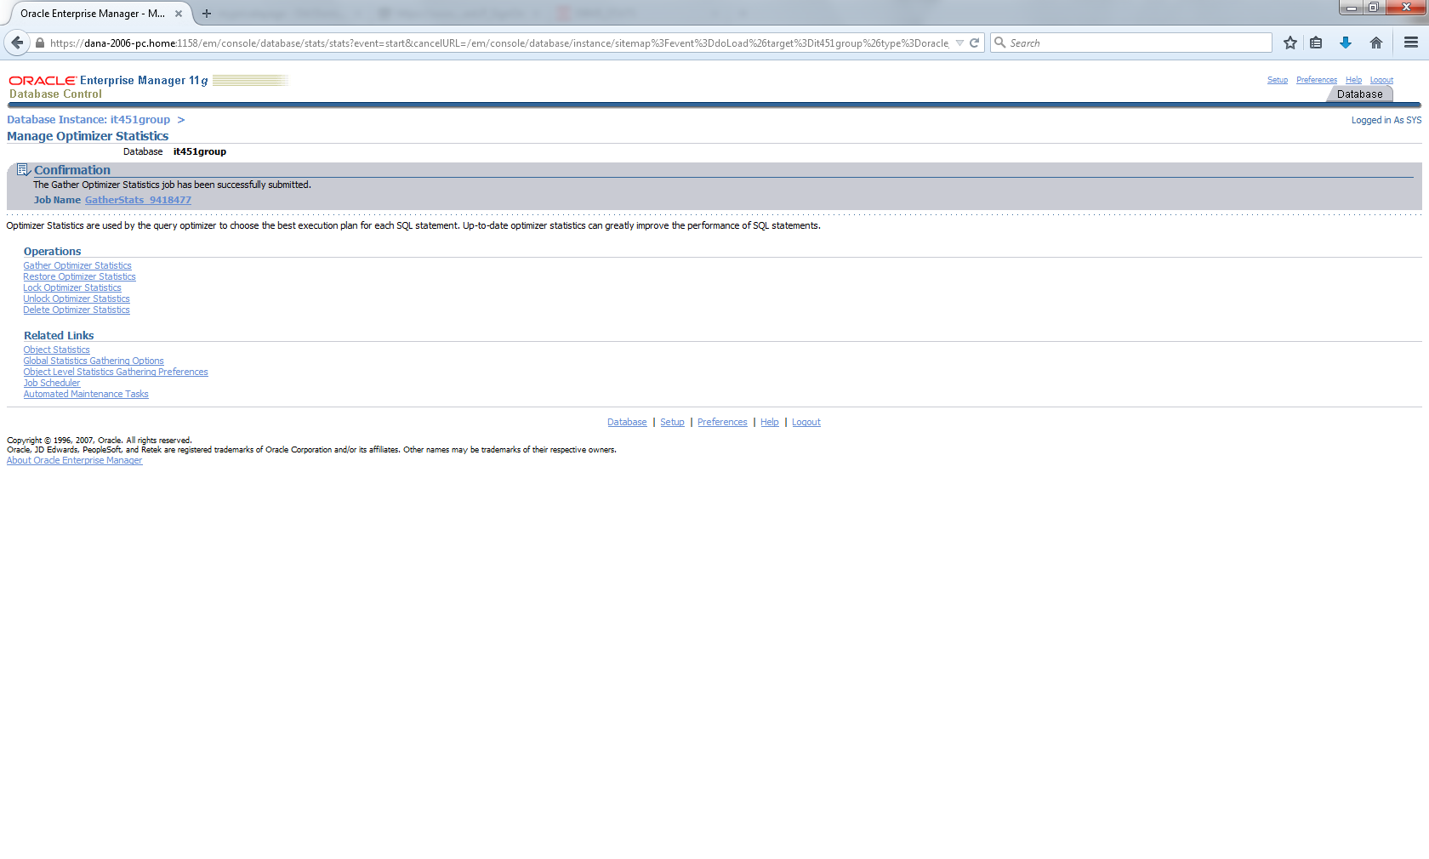

**>Job name: gatherstats 9418477**

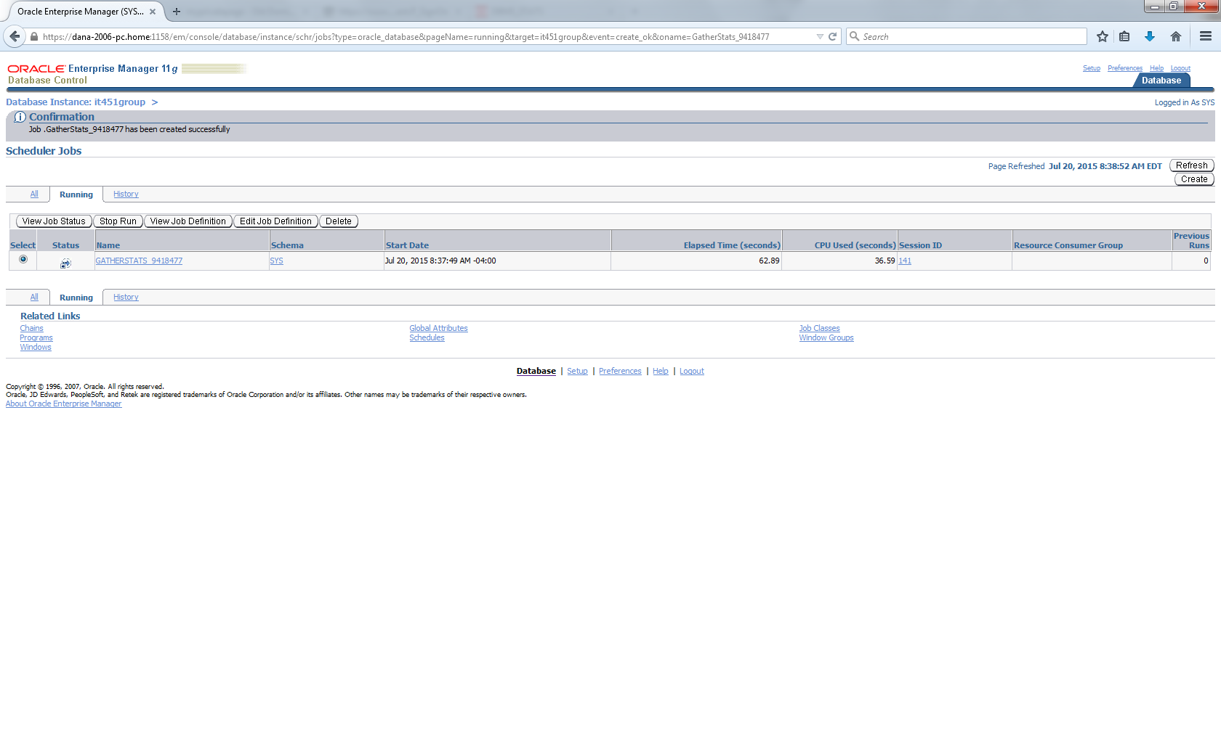

**>shows sql code used here:**

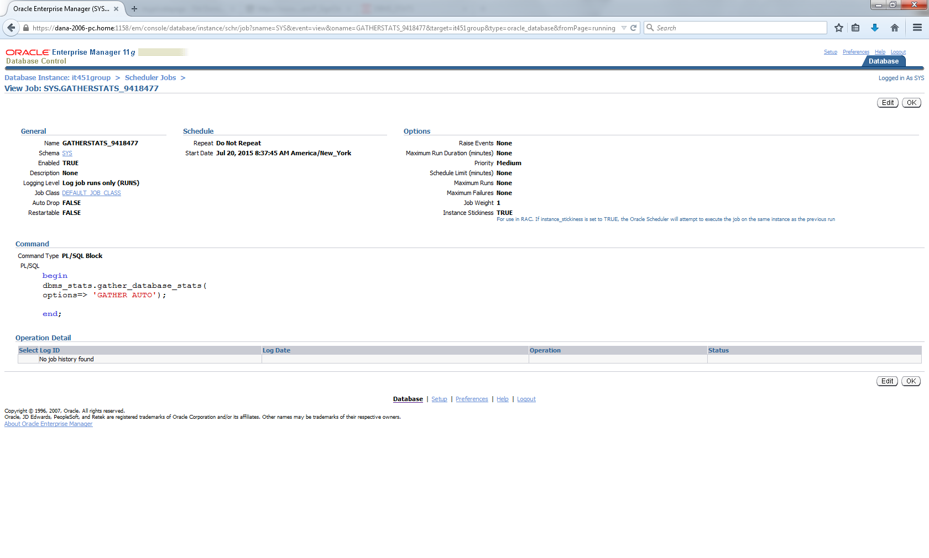

**Schema results:**

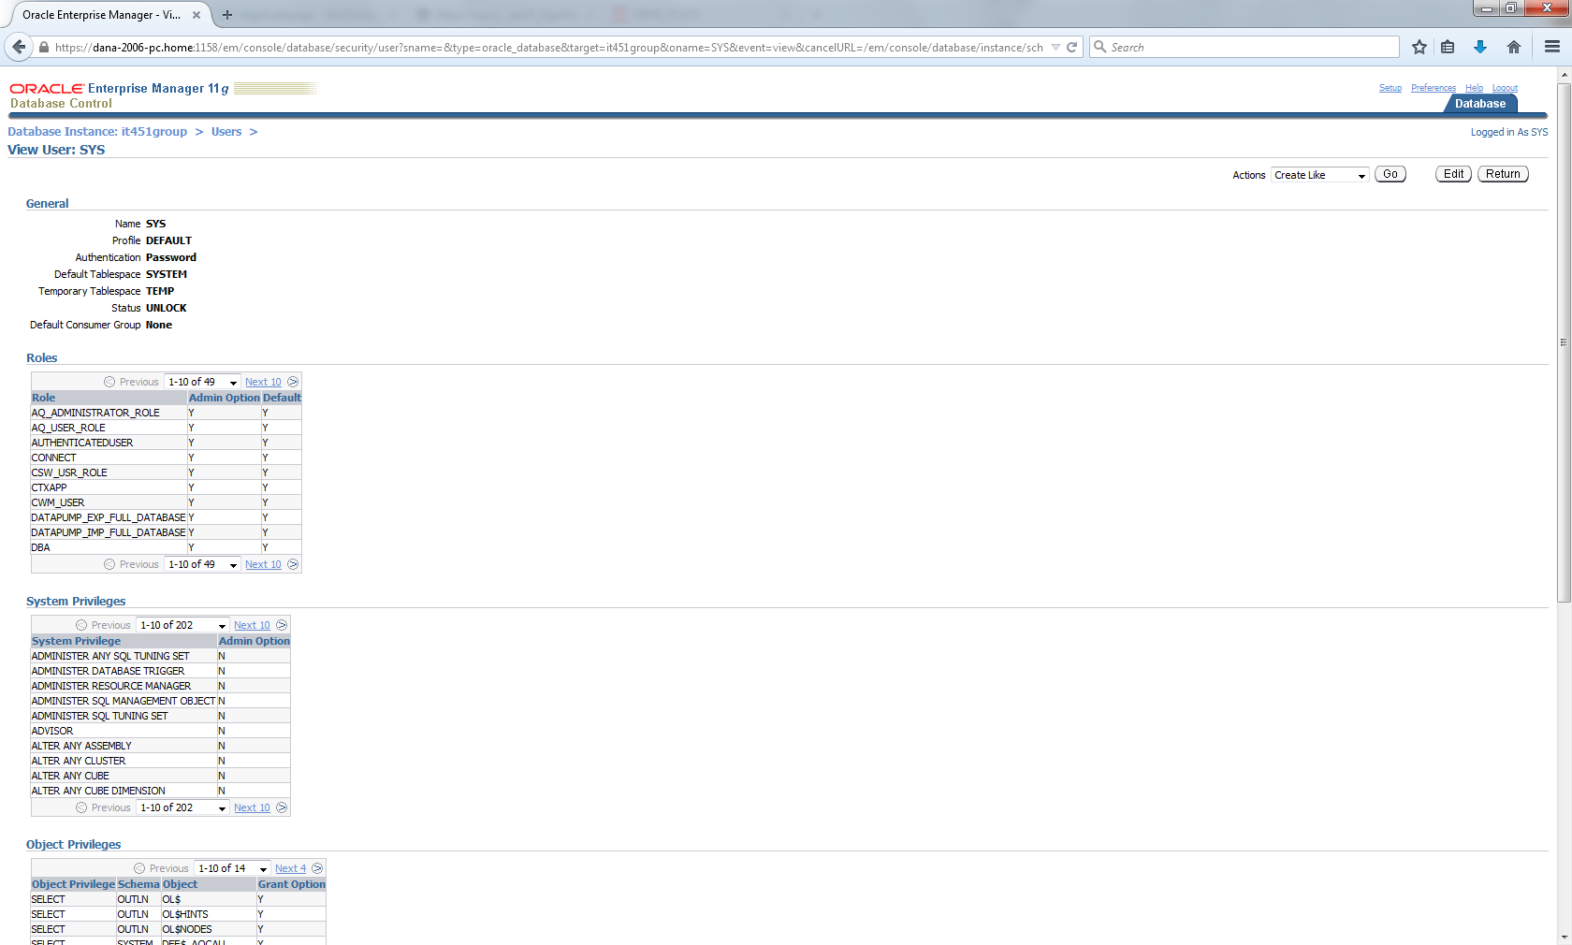

**Continued…..**

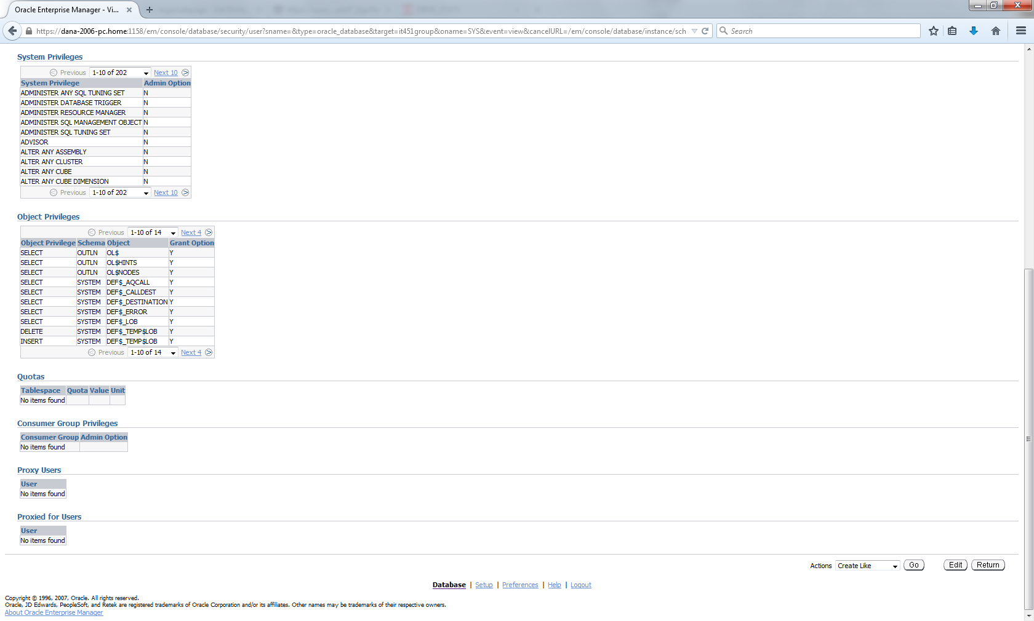

1. **Use database Control to monitor alerts( + alert history)**

**EM >server tab**

**>alert history**

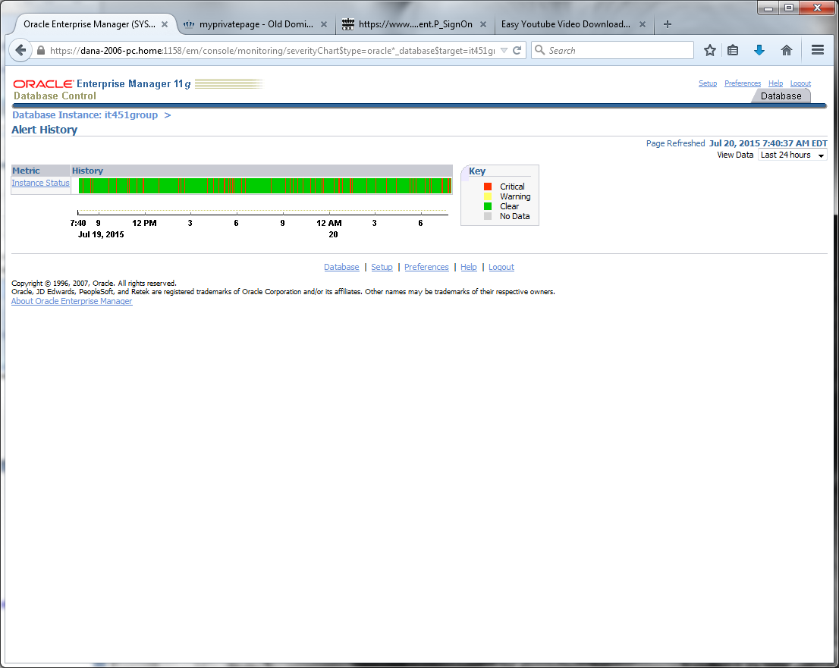

1. **Use database Control to review AWR reports( baseline reports, snapshot reports, and other) .**

**EM >Server Tab**

**>Automatic Workload Repository**

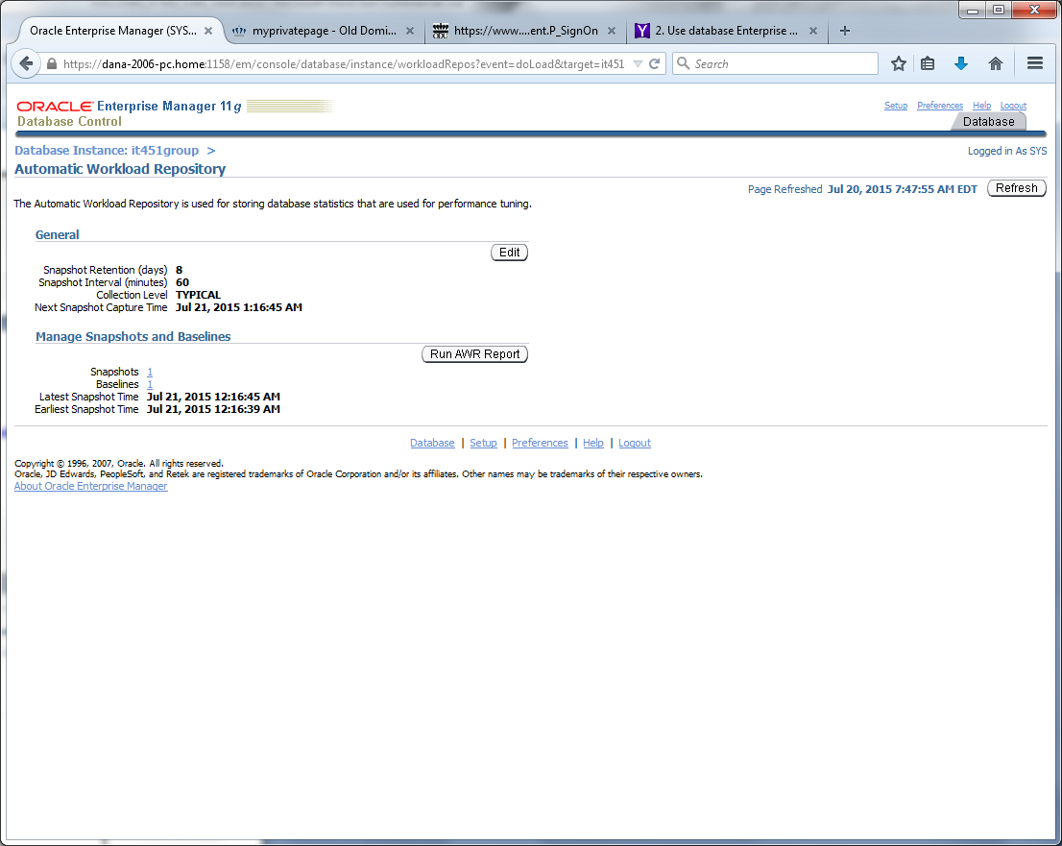

**EM >Server Tab**

**>AWR baselines**

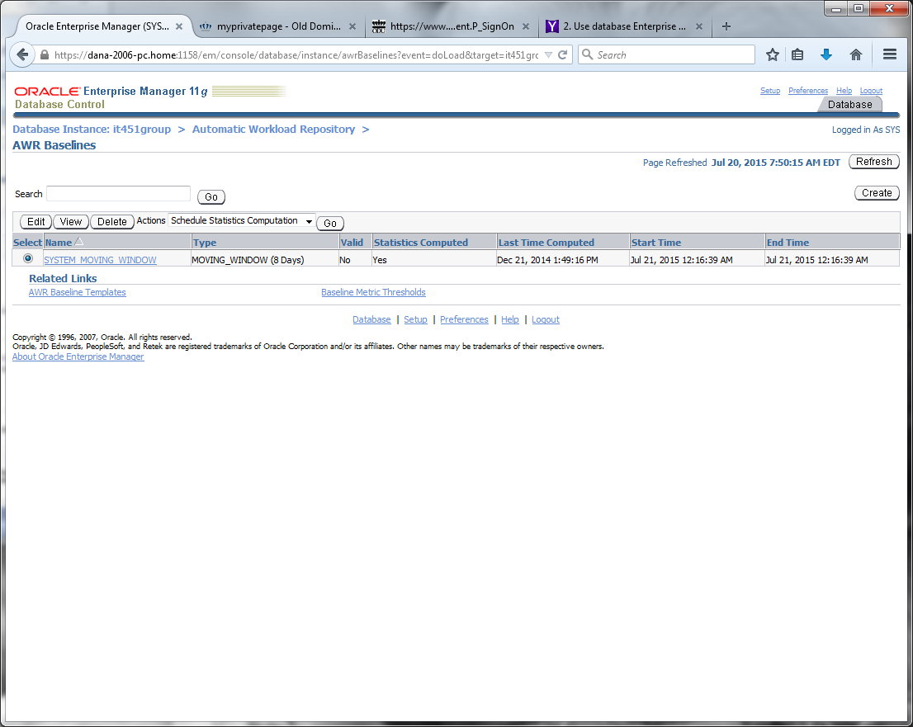

**EM >Server Tab**

**>Automatic Workload Repository**

**>snapshot reports**

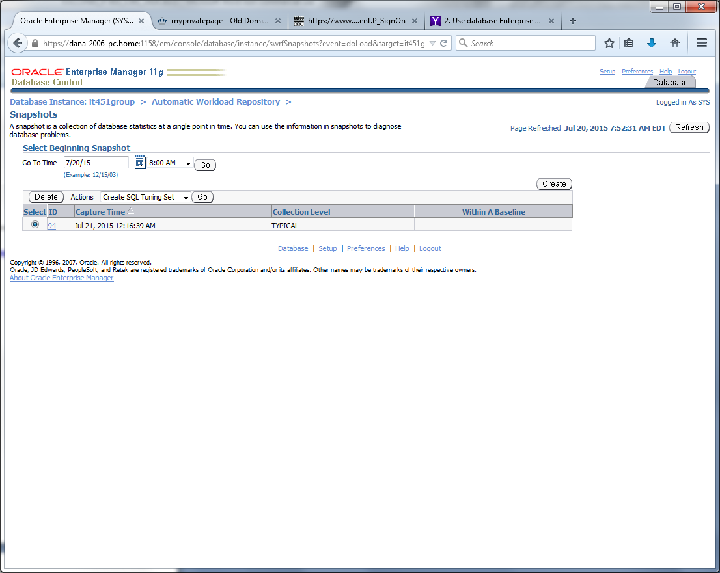

**EM >Server Tab**

**>Automatic Workload Repository**

**>system moving window**

